CIS 481 – Intro to Information Security

CLASS EXERCISE # 6-7

Grading ID: N7149

Problem 1
Review Figure 6-1 from your text and explain the following terms:
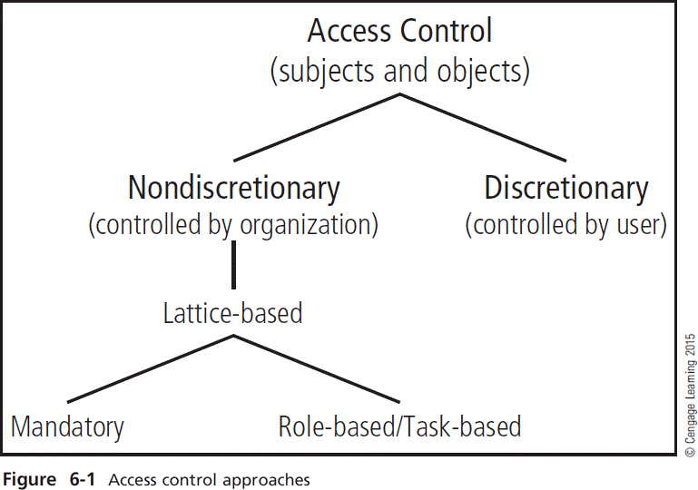
- subjects and object (in access control, not attack)
- discretionary and non-discretionary access control
- lattice-based access control
- mandatory access control
- role-based access control

(15 pts.)
Subjects: a user or system
Object: a resource
Discretionary access controls: access controls that are implemented at the discretion or option of the data user
Non-discretionary access control: access controls that are implemented by a central authority.
Lattice-based access control: a variation on a MAC form of access control, which assigns users a matrix of authorizations for particular areas of access, incorporating the information assets of subjects such as users and objects.
Mandatory access control: a required, structured data classification scheme that rates each collection of information as well as each user.
Role-Based access control: an example of a non-discretionary access control where privileges are tied to the role a user performs in an organization , and are inherited when a user is assigned to that role.

Problem 2
What is stateful inspection? How is state information maintained during a network connection or transaction? What is the primary drawback to the use of this approach? (5 pts.)

Stateful inspection is a firewall type that keeps track of each network connection between internal and external systems using a state table and that expedites the filtering of those communications. State information is maintained during a network connection or transaction using a state table to see if incoming packets match with it or not. If the packet does not match, it refers to its ACL on whether or accept or deny the packet to pass. The primary drawback of using this approach is the additional processing required to manage and verify packets against the state table. If a DoS or DDoS attack were to occur there would be so much processing happening that it slows down the firewall trying to match all of the incoming packets.

Problem 3
How does a network-based IDPS differ from a host-based IDPS? Which has the ability to analyze encrypted packets? (5 pts.)

Host-based IDPS is a IDPS that resides on a particular computer or server, known as a host, and monitors activity only on that systems while a network-based IDPS resides on a computer or appliance connected to a segment of an organization’s network and monitors traffic on that segment, looking for indications of ongoing or successful attacks. A host-based IDPS has the ability to analyze encrypted packets.

