Homework #2: Mastering the Basics of SQL Server
- This is an individual assignment, and is worth 20 points.
- The due date is 2:30 (sec 01) / 7:00 PM (sec 76) on Tuesday, January 28.
- You have to use the “Homework #2-Tasks.docx” file to provide your answers. Change this file name according the naming convention below.
- Use the following naming convention: homework, underscore, last name, first initial, and extension (e.g., Homework #2_ImG.docx). If you do not follow the convention, I will deduct 1.0.
- Do not copy any of the sample screenshots provided as illustrations.
- Report any issues before the deadline.

(Task 1: 5 points) Complete Task #2 through Task #4 while placing your sql files in Queries. Show in a screenshot that your Homework 2 project in Solution Explorer contains three sql files in Solution Explorer.
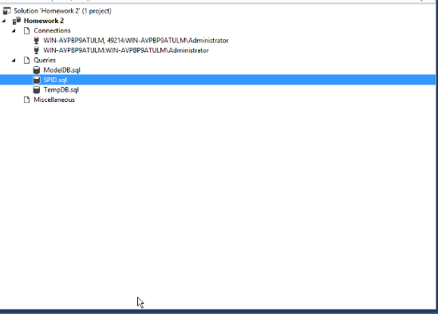

(Task 2: 5 points) Show in a screenshot that DatabaseLog_test table is created in MySecondDatabase, and not in MyFirstDatabase.
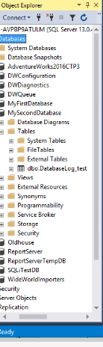
(Task 3: 4 points) Create the three temp tables listed above and show their existence using the SELECT command above. Attach a screenshot.
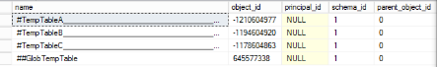
(Question: 1 points) When do we use temporary Tables? List three scenarios. When do we use table variable over temp table? For the answers, go to the link above.
We use Temp tables when:
- When we are doing large number of row manipulation in stored procedures.
- This is useful to replace the cursor. We can store the result set data into a temp table, then we can manipulate the data from there.
- When we are having a complex join operation.
We use variable when Tablevariable is always useful for less data. If the result set returns a large number of records, we need to go for temp table.

(Task 4: 5 points) Fill in all the blanks. Keep in mind that you have made a connection via a dynamic port not the default number. Your answers to the second column must be consistent with the connection you made.
 | Name/Number | Description (definition)
SPID | 55 | This is a service profile identifier, it is just used to identify the service profile
SID | 55 | The SID identifies the security context of the login and is unique within the server instance.
principal_id | 259 | The ID (principal_id) identifies the login as a securable within the server.
net_library | TCP/IP | This is describing the network and what it uses, whether it be TCP, IP, or both.
local_tcp_port | 49214 | This is the local port used to connect to the server.

In addition, show the result of each of the four queries in a screenshot.
