Homework #3: Policy Based Management
- This is an individual assignment, and is worth 20 points.
- The due date is 2:30 (sec 01) / 7:00 PM (sec 76) on Thursday, January 30.
- Use the following naming convention: homework, underscore, last name, first initial, and extension (e.g., Homework #3_ImG.docx). If you do not follow the convention, I will deduct 1.0.

- Screenshots should show the contents of the conditions and policy, not just the names.

- (Task1) Show in a screenshot the condition(s) you created.
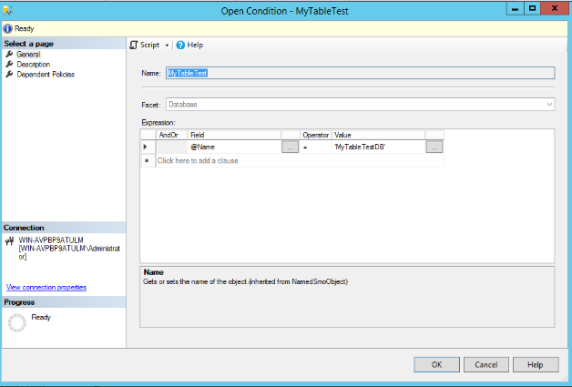
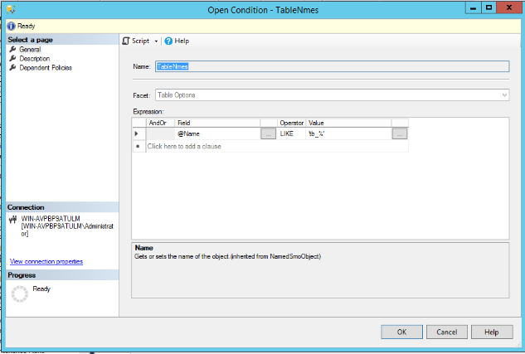
- (Task2) Show in a screenshot the policy you created.
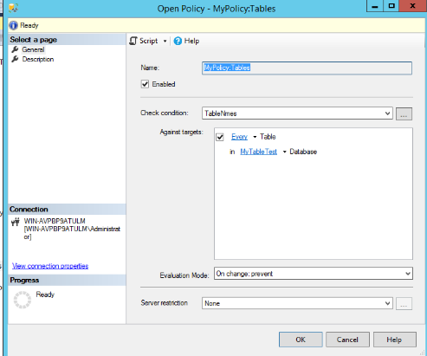
- (Task3) Show in a screenshot the test results using the four tables that are provided above.
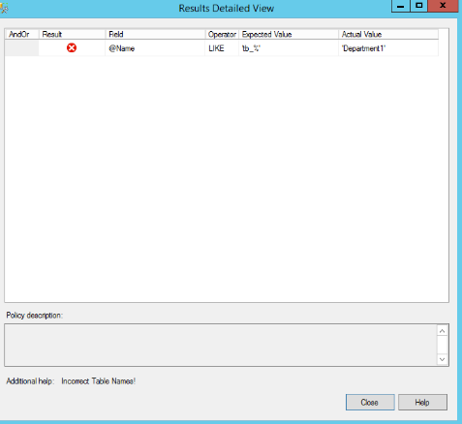
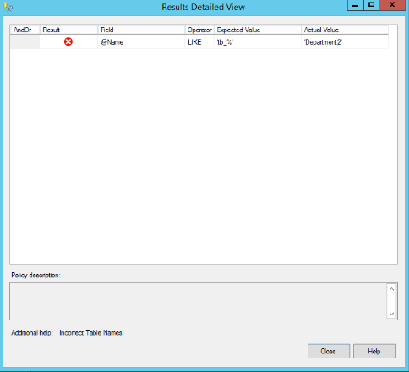
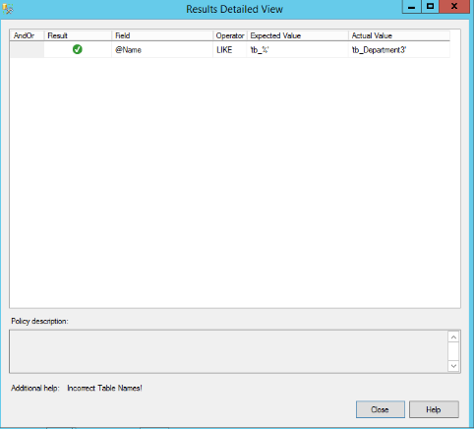
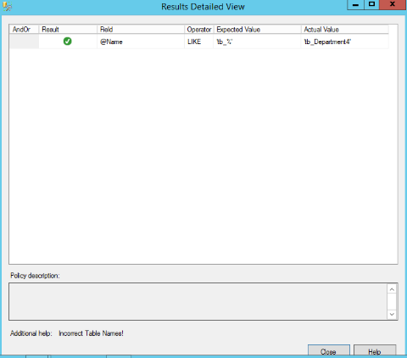

- After this, delete everything you’ve created.

