Homework #6: User Management
- This is an individual assignment, and is worth 20 points.
- The due date is Tuesday, March 17th.
- The database for the assignment - AdventureWorks2016CTP3 – in installed on our Proxmox server. You should download this document after you login to the Proxmox server.
- You should answer the questions in blue.
- You will get deductions if the requested screenshots are not provided.
- Please zoom in your output. I will penalize you if you do not zoom in.

Task #4. Assigning User Mappings to Fixed Database Roles

A. Assigning a user to a database role

B. Verifying the results
5) Does it fail? Show the result in a screenshot. Describe your observation and explain why it fails.
It failed because User A does not have the ability to write. It was put into the role that denies users the ability to write.

10) Does it fail? Show the result in a screenshot. Describe your observation and explain why it fails.
It failed because since User-B was put into the role that denies the ability to read, it was unable to select anything and couldn’t do what was in the query.

Task #5. Creating a Custom Database Role

A. Creating a custom database role

B. Verifying results
4) Does it work? Show the result in a screenshot. Describe your observation and explain why it works.
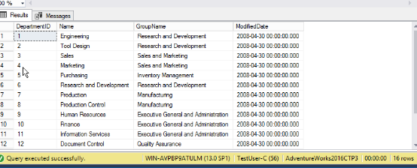
The query works because User C granted the permission of selecting only Human Resources, which is why it shows up when executed.
5) Does it fail? Show the result in a screenshot. Describe your observation and explain why it fails.
It fails because the TestUser-C only has the role of SelectOnly, which means they are only able to select the database, not insert anything.

Task #6. Creating an Application Role

A. Creating an Application Role

B. Verifying Results
2) Does it fail? Show the result in a screenshot. Describe your observation and explain why it fails.
It fails because TestUser-B was not given the new application role, so it was unable to select anything.
4) Does it work? Show the result in a screenshot. You have to click on Results to view the results. Describe your observation and explain why it works.
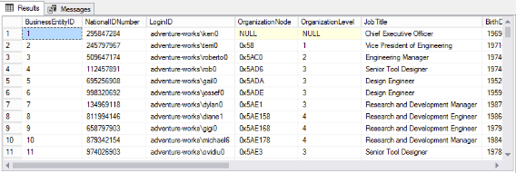
It now works because TestUser-B was granted the new application role so that it could select from the human resources employees.

Task #7. Assigning Permissions
9) Does it work? Show the result in a screenshot. Describe your observation and explain why it works.
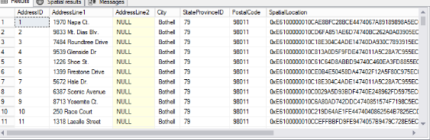
It works because User A was given the permissions to select from the person.addresses table.
13) Run the previous query. Show the result in a screenshot. Describe your observation and explain why it fails.
It fails now because the permission was removed. It can no longer select from that table.
15) Run the previous query. Show the result in a screenshot. Describe your observation and explain why it works. 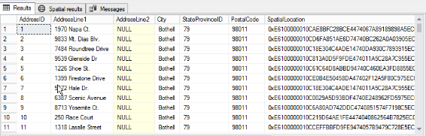
It works now because the user has the role that allows them to read anything in the database.

19) Run the previous query. Show the result in a screenshot. Describe your observation and explain why it fails.

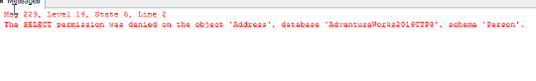
It fails because now that the user was denied the permission to select the table, it can no longer read anything within that table.

